# Case study 0

Link to repository: <https://github.com/kanuto69/ContosoCoffee>

**User accounts**

***Bob***

*Bob will require full admin access as it will be his responsibility to manage and track billing for the Contoso Coffee website and is the owner of Contoso Coffee*

***Dave***

*Dave requires admin access to the resources hosted on Azure for the Contoso Coffee website but not overall administration of the Contoso Coffee subscription*

***Mark***

*Mark will require read-only access to the Contoso Coffee resources.*

The conditons have been met by assigning the roles in Access Manager (IAM) under the resource group ContosoCoffee, and also assigning roles on the Azure AD level.

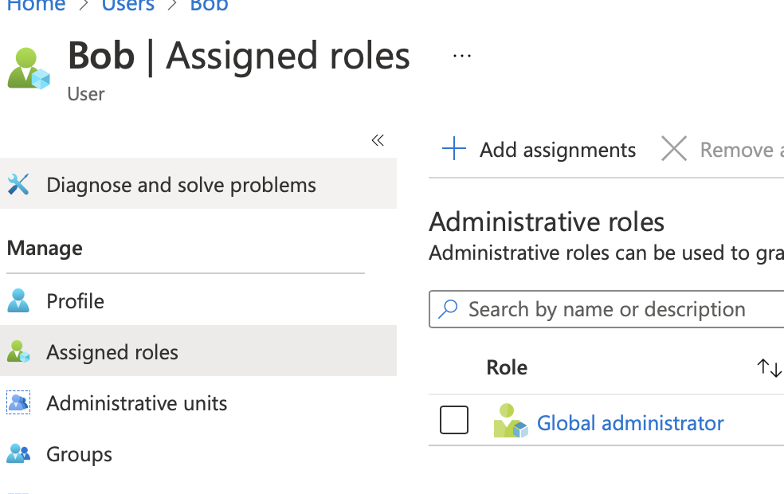

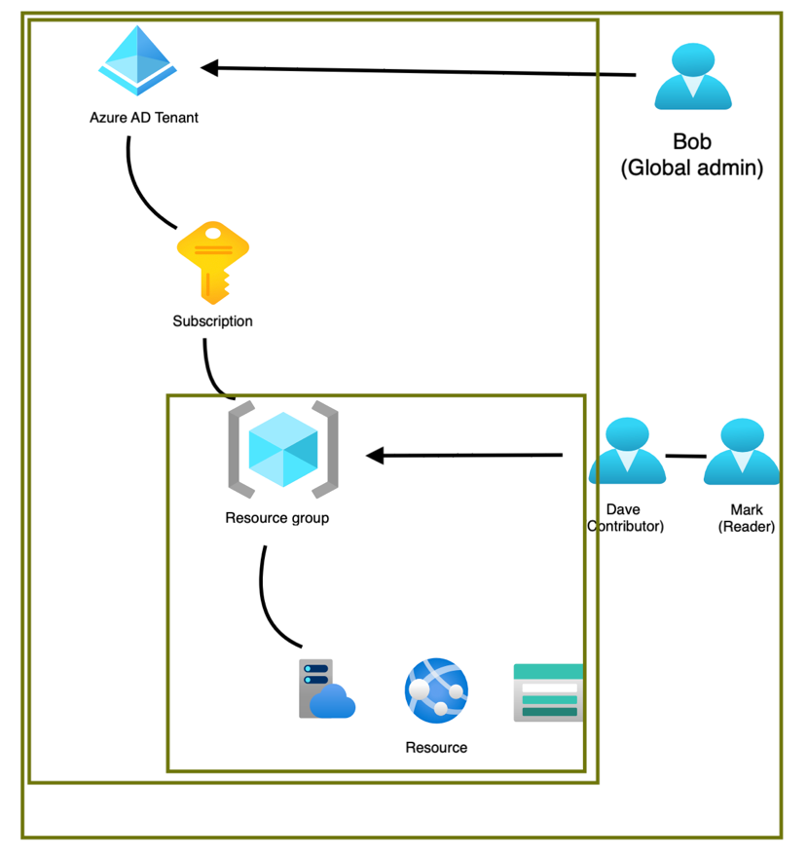

**Website hosting**

The Contoso Coffee website will need to be hosted with a PaaS solution that minimises costs, dynamic scaling of the website is a consideration but not essential. The website should be able to be updated by developers using standard code hosting solutions.

With using App services in Azure, the website is pulled from GitHub through the Deployment Centre. This has been done for both UK South and the US region.

Then I have put up a Load balancer through the Traffic Manager I Azure. See attachments for diagram and working webapps

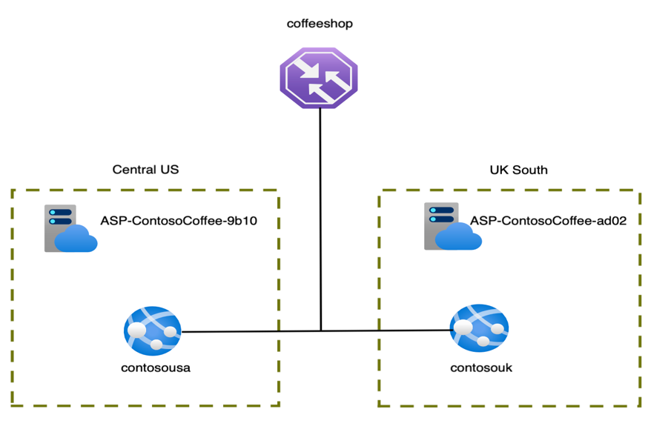

**Contoso Coffee data storage**

Contoso coffee is planning to store a large amount of image information that will be shared with staff members and clients. These images will be scans of 35 and 120 film for hipster photography that will be displayed around the coffee shop. The storage solution should minimise costs by automatically archiving data onto slower storage when required. A SAS key solution should be created for a future image gallery solution to display images on a TV in the Coffee Shop running a small Raspberry Pi solution locally hosting a web page to display the images. Bonus points for creating an image display web app.

I have created a Storage Account with a container, that can store the images that is going to be displayed in the coffee shops. I have set up a Lifecycle management rule to move blobs that have not been modified for 90 days, to archive storage.

Files stored in the container can be shared with a SAS-tokenl

